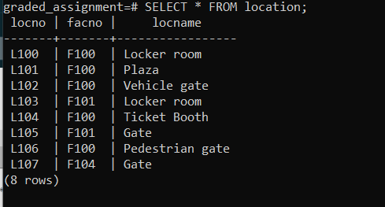

DELETE FROM location

WHERE locno = 'L108';